Vehicle Service Management System

Submitted by:
Karri Himabindu
Kollapu Rishma
Borra Ankitha

Roll No:
24B11CS195
24B11CS215
24B11CS055

Department: CSE
College Name: Aditya University

ABSTRACT
The Vehicle Service Management System is a web-based application developed using Python and Django to automate and streamline the operations of automobile service centers, workshops, and vehicle maintenance organizations. Traditional vehicle servicing processes often rely on manual record-keeping methods, which can lead to data redundancy, delays in service management, difficulty in tracking vehicle history, and reduced customer satisfaction. The proposed system provides a centralized and digital platform to efficiently manage all service-related activities.
The system enables customers to register online, add vehicle details, and book service appointments conveniently. Service advisors can create service requests, generate job cards, assign technicians, and monitor the progress of vehicle repairs. The application maintains complete records of customers, vehicles, service history, spare parts usage, service charges, and payment transactions, ensuring accurate and organized data management.
Administrators are provided with tools to manage customer information, employee details, spare parts inventory, billing processes, and service records. The system also generates invoices automatically and provides various reports related to daily services, pending jobs, inventory status, revenue generation, and customer activity. Customers can view their service history, track the current service status of their vehicles, and receive updates regarding service completion and future maintenance schedules.
The Vehicle Service Management System enhances operational efficiency by reducing paperwork, minimizing human errors, improving resource utilization, and ensuring transparency in service operations. The integration of digital record management and automated workflows enables faster service delivery and better communication between customers and service providers. The system is designed to be secure, scalable, user-friendly, and cost-effective, making it suitable for automobile service centers, garages, dealerships, and vehicle maintenance workshops seeking a modern service management solution.

TABLE OF CONTENTS

Introduction
  - Background of the Project
  - Problem Statement
  - Objectives of the Project
  - Scope of the Project
  - Organization of the Report

Literature Survey
  - Existing Systems
  - Limitations of Existing Systems
  - Proposed System Overview
  - Comparative Study

System Analysis
  - Functional Requirements
  - Non-Functional Requirements
  - Feasibility Study
    - Technical Feasibility
    - Economic Feasibility
    - Operational Feasibility
  - System Constraints
  - Assumptions
  - Summary

System Design
  - Overall Architecture
  - UML Diagrams
    - Use Case Diagram
    - Class Diagram
    - Sequence Diagram
    - Activity Diagram
  - Database Design
    - ER Diagram
    - Table Structure
  - Algorithm Design
  - Flow Charts
  - Design Considerations

Technology Stack
  - Programming Languages
  - Frameworks & Libraries
  - Database Technologies
  - Tools & Platforms
  - Deployment Environment
  - Hardware & Software Requirements
  - Security Technologies
  - Justification of Technology Selection

System Implementation
  - Module Description
    - Admin Module
    - Faculty Module
    - Student Module
    - AI Evaluation Module
  - User Interface Screens
  - Code Snippets (Important Sections)

Testing
  - Testing Strategy
  - Unit Testing
  - Integration Testing
  - System Testing
  - Test Cases & Results

Results & Discussion
  - Output Screens
  - Performance Analysis
  - Comparison with Manual Evaluation
- Security & Data Privacy Considerations
- Advantages of the System
- Limitations of the System
- Future Enhancements
- Conclusion
- References (IEEE Citation Format)
- Appendices
- Database Schema
- Source Code
- User Manual
- Screenshots

Introduction
    - Background of the Project
The Vehicle Service Management System is a web-based application developed using Python and Django to automate and streamline the operations of automobile service centers, garages, and vehicle maintenance workshops. In today's fast-paced environment, vehicle owners expect quick, reliable, and transparent service management. However, many service centers still rely on manual record-keeping methods for maintaining customer information, vehicle details, service history, billing records, and appointment schedules. These traditional approaches are often time-consuming, prone to human errors, and difficult to manage as the number of customers increases.
The proposed Vehicle Service Management System provides a centralized digital platform that enables efficient management of vehicle servicing activities. The system allows customers to register online, schedule service appointments, and track the status of their vehicles. Service advisors can create job cards, assign technicians, monitor service progress, and update repair details. Administrators can manage customer records, spare parts inventory, service charges, employee details, and billing information through a user-friendly interface.
The application maintains comprehensive records of all service-related activities, ensuring accurate data management and easy retrieval of information whenever required. Automated invoice generation, service reminders, inventory tracking, and reporting features further improve the efficiency of service center operations. The system also enhances communication between customers and service providers by providing timely updates regarding service progress and vehicle delivery.
The Vehicle Management System minimizes paperwork, reduces operational costs, improves service Service quality, and increases customer satisfaction. By digitizing the complete service workflow, the system ensures better resource utilization, transparency, and effective decision-making. The project is designed to be scalable, secure, and user-friendly, making it suitable for automobile service centers, authorized dealerships, garages, and vehicle maintenance workshops of various sizes.
The implementation of this system contributes significantly to modernizing vehicle service management processes and supports organizations in delivering efficient and reliable services to their customers.
1.1 Background of the Project
The automobile industry has experienced significant growth over the past few decades, resulting in an increasing demand for vehicle maintenance and repair services. Service centers and workshops are responsible for maintaining detailed records of customer information, vehicle details, service history, spare parts usage, and billing transactions.
Traditionally, these records have been maintained manually using registers, spreadsheets, or paper documents. Such methods are often inefficient, time-consuming, and susceptible to errors. Retrieving historical records, tracking service progress, and managing inventory manually can create operational difficulties and reduce overall productivity.
The advancement of web technologies and database management systems has enabled organizations to automate their service management processes. A web-based Vehicle Service Management System provides a centralized platform where all service-related activities can be managed efficiently. Customers can access services online, while service providers can monitor operations in real time.
The development of this project is motivated by the need to improve service quality, increase operational efficiency, and provide a convenient experience for both customers and service center staff.
1.2 Problem Statement
Many automobile service centers continue to rely on manual methods for managing customer records, vehicle details, service appointments, repair history, spare parts inventory, and billing operations. These traditional approaches create several challenges, including:
• Difficulty in maintaining large volumes of customer and vehicle records.
• Delays in service scheduling and appointment management.
• Lack of transparency in service progress tracking.
• Increased chances of human errors and data duplication.
• Inefficient inventory management.
• Time-consuming invoice preparation and report generation.
• Difficulty in accessing previous service history.
• Reduced customer satisfaction due to poor communication and delayed services.
To overcome these issues, there is a need for an automated system that can efficiently manage vehicle servicing activities while ensuring accuracy, transparency, and reliability.
1.3 Objectives of the Project
primary objective of the Vehicle Service Management System is to automate and streamline vehicle service center operations.
The specific The objectives are:
• To provide online vehicle service appointment booking facilities.
• To maintain customer and vehicle records efficiently.
• To generate and manage service job cards.
• To assign technicians and monitor service activities.
• To maintain complete service history records.
• To manage spare parts inventory effectively.
• To automate billing and invoice generation.
• To generate reports related to services, revenue, and inventory.
• To improve communication between customers and service providers.
• To enhance customer satisfaction through transparent service tracking.
1.4 Scope of the Project
The Vehicle Service Management System is designed to support the daily operations of automobile service centers, garages, and vehicle maintenance workshops.
The scope of the project includes:
• Customer registration and management.
• Vehicle registration and maintenance records.
• Online appointment scheduling.
• Service request management.
• Job card generation.
• Technician assignment and monitoring.
• Spare parts inventory management.
• Billing and invoice generation.
• Service status tracking.
• Report generation and analysis.
The system can be implemented in small, medium, and large-scale service centers. It can also be extended in the future with advanced features such as mobile applications, online payment integration, SMS notifications, and predictive maintenance.
1.5 Organization of the Report
This report is organized into multiple chapters to provide a comprehensive understanding of the Vehicle Service Management System.
Chapter 1 introduces the project, its background, objectives, scope, and overall structure.
Chapter 2 presents the literature survey and discusses existing systems and related studies.
Chapter 3 describes system analysis, including functional requirements, non-functional requirements, feasibility studies, and constraints.
Chapter 4 explains the system design, architecture, UML diagrams, database design, algorithms, and flowcharts.
Chapter 5 discusses the technology stack, development tools, software requirements, and security technologies used in the project.
Chapter 6 presents the system implementation details, modules, user interfaces, and important code sections.
Chapter 7 describes the testing methodologies, test cases, and testing results.
Chapter 8 discusses the project results, performance analysis, and comparison with traditional methods.
Chapter 9 presents security considerations, advantages, limitations, future enhancements, and the final conclusion of the project.

2.Literature Survey
2.1Existing Systems
Vehicle service management plays an important role in the automobile industry by ensuring proper maintenance and repair of vehicles. Traditionally, many automobile workshops and service centers use manual methods such as paper records, registers, and spreadsheets to maintain customer information, vehicle details, service history, inventory records, and billing information. These methods have been used for many years due to their simplicity and low initial cost.
Some service centers utilize standalone software applications for maintaining customer records and billing operations. While these applications provide basic functionality, they often lack integration between different departments such as inventory management, technician assignment, appointment scheduling, and customer communication. As a result, managing service operations efficiently becomes difficult.
Modern vehicle service centers have started adopting computerized systems to improve service quality and operational efficiency. These systems help automate appointment scheduling, service tracking, invoice generation, and inventory management. However, many existing solutions are expensive, difficult to customize, or limited to specific business requirements.
Several commercial service management applications are available in the market. These systems provide features such as customer management, vehicle tracking, spare parts inventory management, billing, and reporting. Despite offering advanced functionalities, many small and medium-sized service centers find them costly and complex to implement.
With the increasing adoption of web technologies, organizations are moving towards web-based service management systems. These systems provide centralized access to information, real-time updates, improved security, and better customer engagement. The proposed Vehicle Service Management System is designed to provide these benefits while maintaining simplicity, scalability, and affordability.
2.2 Limitations of Existing Systems
Although existing vehicle service management solutions provide various useful features, they still suffer from several limitations that affect operational efficiency and customer satisfaction.
The major limitations of existing systems are as follows:
• Dependence on manual record keeping in many workshops.
• Increased paperwork and storage requirements.
• Difficulty in maintaining large volumes of customer and vehicle data.
• Lack of real-time service status tracking.
• Poor communication between customers and service providers.
• Delays in appointment scheduling and service delivery.
• High probability of human errors during data entry.
• Difficulty in retrieving historical service records.
• Inefficient inventory management practices.
• Limited reporting and analytical capabilities.
• Lack of integration among different service center activities.
• High implementation and maintenance costs for commercial solutions.
• Limited customization options according to organizational requirements.
• Data redundancy and inconsistency issues.
• Reduced transparency in service operations.
These limitations indicate the need for an efficient and integrated vehicle service management solution capable of automating the complete service workflow.
2.3 Proposed System Overview
The proposed Vehicle Service Management System is a web-based application developed using Python and Django to automate and simplify vehicle servicing operations. The system provides a centralized platform that integrates customer management, vehicle records, appointment scheduling, service tracking, inventory management, billing, and reporting functionalities.
The system allows customers to register online and schedule service appointments by providing vehicle details and selecting required services. Service advisors can create job cards, assign technicians, monitor repair progress, and update service information throughout the servicing process.
Administrators can manage customer records, employee information, spare parts inventory, service charges, and billing details through a secure dashboard. The system automatically generates invoices and maintains detailed records of all service activities.
Customers can view service history, track vehicle status, and receive notifications regarding service completion and future maintenance schedules. The application also provides reports and dashboards for monitoring service performance, revenue generation, pending jobs, and inventory availability.
The proposed system offers a user-friendly interface, centralized database management, improved security, and efficient workflow automation. By digitizing service center operations, the system helps organizations improve productivity, reduce costs, and enhance customer satisfaction.
Key Features of the Proposed System
• Customer Registration and Management
• Vehicle Registration and Tracking
• Online Appointment Scheduling
• Job Card Generation
• Technician Assignment
• Service Progress Monitoring
• Spare Parts Inventory Management
• Billing and Invoice Generation
• Service History Maintenance
• Reporting and Analytics
• Secure User Authentication
• Customer Notifications
• Dashboard-Based Monitoring
2.4 Comparative Study
A comparative study helps evaluate the advantages of the proposed system over traditional and existing service management methods.
Feature | Manual System | Existing Software | Proposed System
Customer Record Management | Difficult | Moderate | Efficient
Vehicle Service Tracking | Manual | Partial | Real-Time
Appointment Scheduling | Manual | Limited | Automated
Inventory Management | Difficult | Available | Integrated
Billing Process | Manual | Semi-Automated | Fully Automated
Report Generation | Time Consuming | Available | Instant
Data Security | Low | Medium | High
Service History Retrieval | Difficult | Moderate | Easy
Technician Assignment | Manual | Partial | Automated
Customer Notifications | Not Available | Limited | Available
Scalability | Low | Medium | High
Maintenance Cost | High | Medium | Low
User Friendliness | Low | Medium | High
From the above comparison, it can be observed that the proposed Vehicle Service Management System provides better integration, automation, security, and efficiency compared to traditional manual methods and many existing software solutions.
The proposed system significantly reduces paperwork, improves service transparency, enhances communication, and ensures accurate record maintenance. These benefits contribute to improved operational performance and customer satisfaction.
2.5 Summary
This chapter presented a detailed literature survey of existing vehicle service management approaches and technologies. The study examined traditional manual systems, existing software solutions, and their associated limitations. The analysis revealed several challenges such as inefficient record management, lack of automation, poor communication, and limited reporting capabilities.
To address these issues, a web-based Vehicle Service Management System has been proposed. The proposed solution integrates customer management, vehicle servicing, inventory control, billing, and reporting functionalities into a single platform. A comparative study demonstrated the advantages of the proposed system in terms of efficiency, security, automation, and usability.
The findings of this literature survey provide a strong foundation for the design and development of the Vehicle Service Management System discussed in the subsequent chapters.

3.System Analysis

Functional Requirements
Functional requirements define the specific services and functionalities that the Vehicle Service Management System must provide to users. These requirements describe the operations performed by the system and the interactions between users and system components.

3.1.1 Customer Registration and Management
The system shall allow customers to register by providing personal information such as name, contact number, email address, and address. Customers can update their profile details and manage their account information.

3.1.2 Vehicle Registration and Management
Customers shall be able to register their vehicles by entering details such as vehicle number, model, manufacturer, fuel type, and registration information. The system shall maintain records of all registered vehicles.

3.1.3 Service Appointment Scheduling
Customers shall be able to book service appointments online by selecting suitable dates and service categories. The system shall maintain appointment schedules and avoid booking conflicts.

3.1.4 Job Card Generation
Service advisors shall be able to generate job cards containing vehicle information, customer complaints, service requirements, technician assignments, and repair details.

3.1.5 Technician Management
The system shall maintain technician records and assign service jobs based on availability and expertise.

3.1.6 Service Status Tracking
The system shall allow customers and staff members to track the progress of vehicle servicing activities from initiation to completion.

3.1.7 Spare Parts Inventory Management
The system shall manage spare parts inventory by maintaining stock records, tracking usage, and updating inventory levels automatically.

3.1.8 Billing and Invoice Generation
The system shall calculate service charges, spare parts costs, taxes, and generate invoices automatically.

3.1.9 Service History Management
The system shall maintain complete service history records for every vehicle serviced in the workshop.

3.1.10 Report Generation
The system shall generate reports related to customer activities, service records, inventory status, revenue, and technician performance.

3.1.11 Authentication and Authorization
The system shall provide secure login functionality and role-based access control for administrators, service advisors, technicians, and customers.

3.2 Non-Functional Requirements
Non-functional requirements define the quality attributes of the Vehicle Service Management System.

3.2.1 Performance
The system should provide fast response times and process service-related requests efficiently.

3.2.2 Reliability
The system should function continuously without failures and ensure accurate processing of information.

3.2.3 Security
The system should protect customer, vehicle, and billing information from unauthorized access.

3.2.4 Scalability
The system should support increasing numbers of customers, vehicles, and service requests without performance degradation.

3.2.5 Availability
The system should be available whenever users need access to its services.

3.2.6 Maintainability
The application should be easy to maintain, upgrade, and modify.

3.2.7 Usability
The system should provide a user-friendly interface that requires minimal training.

3.2.8 Portability
The application should operate across multiple operating systems and web browsers.

3.2.9 Data Integrity
The system should maintain consistent and accurate data throughout all operations.

3.2.10 Backup and Recovery
The system should support data backup and recovery mechanisms to prevent data loss.

3.3 Feasibility Study
A feasibility study evaluates whether the proposed Vehicle Service Management System can be successfully developed and implemented.
The study examines technical, economic, and operational aspects of the project.

3.3.1 Technical Feasibility
Technical feasibility determines whether the required technology, tools, and expertise are available for project development.
The proposed system uses:
• Python Programming Language
• Django Framework
• HTML, CSS, JavaScript
• Bootstrap
• MySQL Database
• Visual Studio Code
• GitHub Version Control
These technologies are widely used, reliable, and suitable for developing modern web applications.
Advantages of technical feasibility include:
• Availability of open-source technologies
• Ease of development and maintenance
• Strong community support
• High scalability
• Secure web framework
The development team possesses the required technical skills to implement the system successfully.
Therefore, the project is technically feasible.

3.3.2 Economic Feasibility
Economic feasibility analyzes whether the project benefits outweigh the costs involved.

Development Costs
• Software development cost
• System deployment cost
• Training cost
• Maintenance cost

Benefits
• Reduced paperwork
• Reduced administrative expenses
• Improved employee productivity
• Faster service delivery
• Better customer satisfaction
• Efficient inventory management
• Improved revenue tracking
Since open-source technologies are used, implementation costs remain low while long-term benefits are significant.
Therefore, the project is economically feasible.

3.3.3 Operational Feasibility
Operational feasibility determines whether the proposed system can function effectively within the organization.
The Vehicle Service Management System provides:
• User-friendly interfaces
• Automated workflows
• Real-time service tracking
• Easy report generation
• Efficient communication
• Improved record management
Employees can easily adapt to the system with minimal training. Customers can also use the platform conveniently for appointment booking and service tracking.
Therefore, the project is operationally feasible.

3.4 System Constraints
System constraints are limitations that may affect the implementation and operation of the Vehicle Service Management System.

3.4.1 Budget Constraints
The project must be completed within the allocated budget.

3.4.2 Time Constraints
Development activities should be completed within the specified project duration.

3.4.3 Internet Connectivity
The web-based application requires stable internet connectivity for proper functioning.

3.4.4 Security Constraints
Customer and vehicle information must be protected against unauthorized access and cyber threats.

3.4.5 Hardware Limitations
System performance depends on server resources and hardware infrastructure.

3.4.6 User Adaptation
Some users may require training to become familiar with the new system.

3.4.7 Database Dependency
The application relies on continuous database availability for performing operations.

3.5 Assumptions
The following assumptions are made during the development of the Vehicle Service Management System:
• Users possess basic computer literacy.
• Customers provide accurate information during registration.
• Internet connectivity is available whenever the system is accessed.
• Database servers remain operational.
• Service center staff update service information regularly.
• Inventory records are maintained accurately.
• Authorized users protect their login credentials.
• Vehicle details entered into
the system are valid.
• Management supports digital transformation initiatives.
• Adequate hardware resources are available for system deployment.
These assumptions establish the operational environment of the proposed system.

3.6 Summary
This chapter presented the detailed system analysis of the Vehicle Service Management System. The functional requirements defined the core services including customer management, vehicle registration, appointment scheduling, job card generation, technician management, inventory control, billing, and reporting. Non-functional requirements described the quality attributes such as performance, security, reliability, scalability, and usability.
A feasibility study was conducted to evaluate the project's technical, economic, and operational viability. The analysis confirmed that the system can be implemented successfully using available technologies and resources. System constraints and assumptions were also identified to understand the environment in which the application will operate.

4.System Design
4.1 Introduction
System Design is the process of transforming the requirements identified during system analysis into a detailed blueprint for system development. It defines the architecture, components, modules, interfaces, and database structure required to implement the Vehicle Service Management System. A well-designed system ensures efficiency, reliability, scalability, and maintainability.
The Vehicle Service Management System is designed as a web-based application using Python and Django. The system integrates customer management, vehicle management, appointment scheduling, service tracking, inventory management, billing, and reporting functionalities into a single platform. The design focuses on providing an easy-to-use interface while ensuring secure and efficient management of service center operations.
4.2 Overall Architecture
The Vehicle Service Management System follows a Three-Tier Architecture consisting of:
1. Presentation Layer
The presentation layer acts as the user interface through which users interact with the system. It provides web pages for registration, login, appointment booking, vehicle management, billing, and reporting.
Technologies Used:
• HTML
• CSS
• Bootstrap
• JavaScript
2. Business Logic Layer
The business logic layer handles all processing activities and implements the core functionalities of the system.
Responsibilities:
• Authentication
• Appointment Management
• Service Management
• Inventory Management
• Billing Management
• Report Generation
Technology Used:
• Python
• Django Framework

3. Database Layer
The database layer stores and manages all information related to customers, vehicles, services, appointments, technicians, inventory, and billing.
Technology Used:
• MySQL
System Architecture Diagram
Customer → Web Browser → Django Application → MySQL Database
Administrator → Web Browser → Django Application → MySQL Database
Service Advisor → Web Browser → Django Application → MySQL Database
Technician → Web Browser → Django Application → MySQL Database
(Insert Architecture Diagram Here)
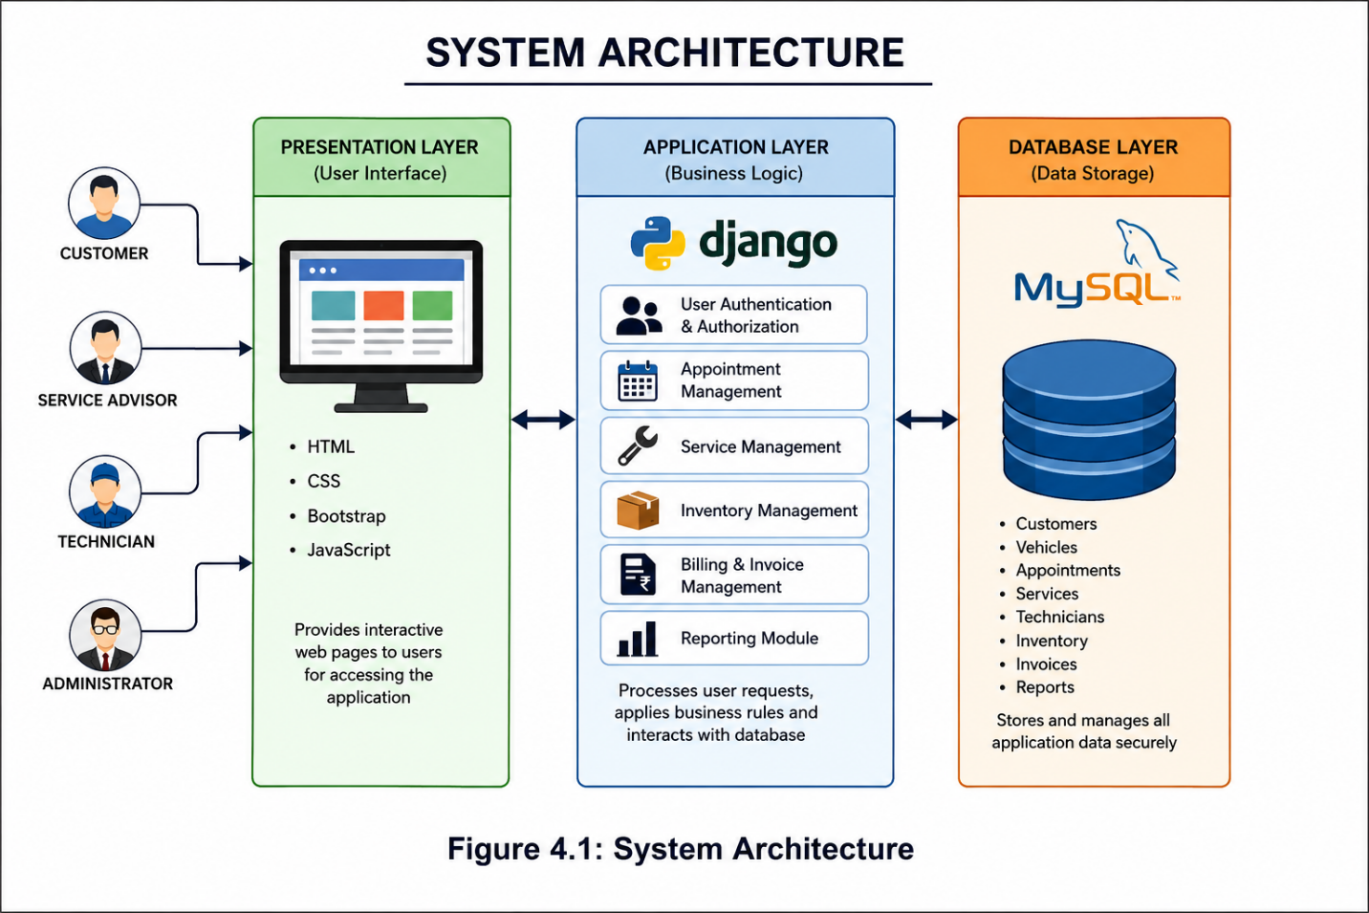
4.3 UML Diagrams
Unified Modeling Language (UML) diagrams are graphical representations used to visualize system structure and behavior.
4.3.1 Use Case Diagram
The Use Case Diagram represents interactions between users and the system.
Actors
• Customer
• Service Advisor
• Technician
• Administrator
Customer Activities
• Register
• Login
• Add Vehicle
• Book Service Appointment
• View Service Status
• View Service History
• View Invoice
Service Advisor Activities
• Create Job Card
• Assign Technician
• Update Service Information
• Generate Invoice
Technician Activities
• View Assigned Tasks
• Update Service Status
• Complete Repairs

Administrator Activities
• Manage Customers
• Manage Employees
• Manage Inventory
• Generate Reports
• Manage Services
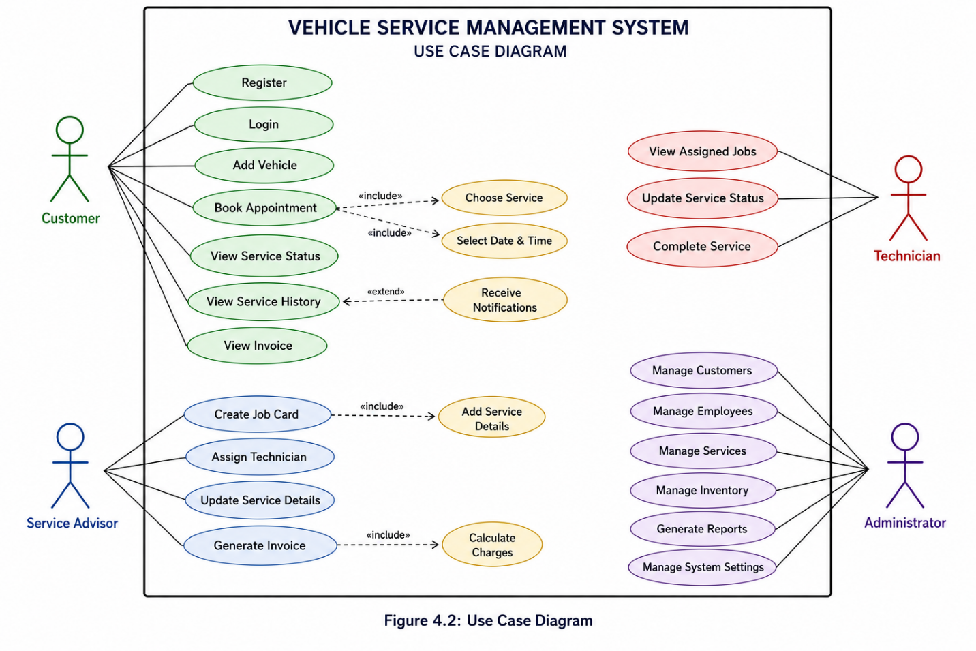
4.3.2 Class Diagram
The Class Diagram illustrates the structure of classes and their relationships.
Customer Class
Attributes:
• customer_id
• customer_name
• email
• phone
• address
Methods:
• register()
• login()
• updateProfile()
Vehicle Class
Attributes:
• vehicle_id
• vehicle_number
• model
• manufacturer
Methods:
• addVehicle()
• updateVehicle()
Attributes:
• appointment_id
• appointment_date
• service_type
Methods:
• scheduleAppointment()
• cancelAppointment()
Technician Class
Attributes:
• technician_id
• technician_name
• specialization
Methods:
• updateStatus()
• completeTask()
Invoice Class
Attributes:
• invoice_id
• amount
• invoice_date
Methods:
• generateInvoice()
• printInvoice()
(Insert Class Diagram Here)
4.3.3 Sequence Diagram
The Sequence Diagram shows the interaction between system objects over time.
Appointment Booking Process
Customer → Login
Customer → Select Vehicle
Customer → Select Service
Customer → Choose Date
System → Validate Request
System → Save Appointment
System → Generate Appointment ID
System → Display Confirmation
Customer → Receives Confirmation
Service Completion Process
Service Advisor → Create Job Card
System → Assign Technician
Technician → Perform Service
Technician → Update Status
System → Generate Invoice
Customer → Receive Service Completion Notification
(Insert Sequence Diagram Here)
4.3.4 Activity Diagram
The Activity Diagram represents workflow activities of the system.
Service Workflow
Start
↓
Customer Registration
↓
Vehicle Registration
↓
Appointment Booking
↓
Job Card Creation
↓
Technician Assignment
↓
Vehicle Inspection
↓
Repair and Maintenance
↓
Service Completion
↓
Invoice Generation
↓
Payment
↓
Vehicle Delivery
↓
End
(Insert Activity Diagram Here)
4.4 Database Design
Database design is responsible for organizing system data in a structured and efficient manner.
Objectives of Database Design
• Reduce data redundancy
• Improve data consistency
• Ensure data security
• Enable efficient retrieval
• Support scalability
Main Database Entities
• Customer
• Vehicle
• Appointment
• Technician
• Job Card
• Inventory
• Invoice
• Service History
4.4.1 ER Diagram
The Entity Relationship Diagram (ERD) describes relationships among system entities.

Relationships
• One Customer owns multiple Vehicles.
• One Vehicle can have multiple Service Records.
• One Appointment generates one Job Card.
• One Technician can perform multiple Service Tasks.
• One Invoice is generated for each completed service.
• Multiple Spare Parts may be used in one service.
(Insert ER Diagram Here)
4.4.2 Table Structure
Customer Table
Field Name | Data Type
customer_id | INT
customer_name | VARCHAR(100)
email | VARCHAR(100)
phone | VARCHAR(15)
address | TEXT
Vehicle Table
Field Name | Data Type
vehicle_id | INT
customer_id | INT
vehicle_number | VARCHAR(20)
model | VARCHAR(50)
manufacturer | VARCHAR(50)
Appointment Table
Technician Table
Field Name | Data Type
technician_id | INT
technician_name | VARCHAR(100)
specialization | VARCHAR(100)
Invoice Table
Field Name | Data Type
invoice_id | INT
amount | DECIMAL
invoice_date | DATE

4.5 Algorithm Design
Algorithm for Vehicle Service Appointment
Step 1: Start
Step 2: Customer Login
Step 3: Select Vehicle
Step 4: Choose Service Type
Step 5: Select Appointment Date
Step 6: Check Availability
Step 7: Store Appointment Details
Step 8: Generate Appointment ID
Step 9: Display Confirmation
Step 10: End
Algorithm for Invoice Generation
Step 1: Start
Step 2: Retrieve Service Information
Step 3: Calculate Service Charges
Step 4: Calculate Spare Parts Cost
Step 5: Calculate Total Amount
Step 6: Generate Invoice
Step 7: Save Invoice
Step 8: Display Invoice
Step 9: End
4.6 Flow Charts
Appointment Booking Flowchart
Start
↓
Customer Login
↓
Select Vehicle
↓
Choose Service
↓
Select Date
↓
Confirm Appointment
↓
Appointment Generated
↓
End
Vehicle Service Flowchart
Start
↓
Vehicle Received
↓
Job Card Created
↓
Technician Assigned
↓
Service Performed
↓
Status Updated
↓
Invoice Generated
↓
Payment Completed
↓
Vehicle Delivered
↓
End
(Insert Flowchart Here)
4.7 Summary
This chapter presented the complete design of the Vehicle Service Management System. The overall architecture, UML diagrams, database structure, algorithms, and flowcharts were discussed in detail. The design provides a clear framework for implementing the application and ensures that all system requirements are effectively addressed. The modular architecture and efficient database design contribute to improved system performance, maintainability, security, and scalability.

5.TECHNOLOGY STACK
5.1 Programming Languages
Programming languages form the foundation of software development. The Vehicle Service Management System is developed using Python as the primary programming language.
Python
Python is a high-level, interpreted, and object-oriented programming language known for its simplicity, readability, and extensive library support. It is widely used for web development, data processing, automation, and software engineering.
Features of Python
• Easy to learn and use
• Platform independent
• Open-source language
• Supports Object-Oriented Programming
• Large collection of libraries
• High development speed
Advantages of Python
• Reduced development time
• Improved code readability
• Strong community support
• Easy integration with databases
• Excellent support for web frameworks such as Django
Python serves as the backend programming language for implementing business logic and server-side operations in the Vehicle Service Management System.
5.2 Frameworks & Libraries
Frameworks and libraries simplify software development by providing pre-built components and functionalities.
Django Framework
Django is a high-level Python web framework that enables rapid development of secure and maintainable web applications.
Features of Django
• Built-in Authentication System
• URL Routing
• ORM (Object Relational Mapping)
• Security Features
• Admin Panel
• Template Engine
Benefits of Django
• Faster Development
• Enhanced Security
• Scalability
• Reusable Components
• Database Integration
The Vehicle Service Management System uses Django to implement user authentication, appointment scheduling, service management, inventory management, and reporting functionalities.
Bootstrap
Bootstrap is a popular frontend framework used for designing responsive and visually appealing web pages.
Features
• Responsive Layout
• Mobile-Friendly Design
• Ready-Made Components
• Cross-Browser Compatibility
JavaScript
JavaScript is used to improve user interaction and provide dynamic functionality within web pages.
Applications include:
• Form Validation
• Dynamic Content Updates
• User Interface Enhancements

5.3 Database Technologies
A database management system is required to store and manage application data efficiently.
MySQL
MySQL is a relational database management system used for storing customer records, vehicle details, appointments, inventory data, and billing information.
Features of MySQL
• High Performance
• Reliability
• Data Security
• Scalability
• Multi-user Support
Advantages
• Easy Database Management
• Fast Data Retrieval
• Structured Data Storage
• Strong Security Features
• Open Source
Database Usage in the Project
The MySQL database stores:
• Customer Information
• Vehicle Details
• Appointment Records
• Technician Information
• Spare Parts Inventory
• Service History
• Billing Information
• Reports and Logs
5.4 Tools & Platforms
Various development tools are used during the implementation of the Vehicle Service Management System.
Visual Studio Code (VS Code)
Visual Studio Code is the primary code editor used for project development.
Features
• Syntax Highlighting
• Debugging Support
• Extension Marketplace
• Git Integration
• Lightweight Environment

Git
Git is a distributed version control system used for source code management.
Benefits
• Version Tracking
• Collaboration Support
• Code Backup
• Change Management
GitHub
GitHub is a cloud-based platform used for hosting project repositories.
Features
• Code Storage
• Collaboration
• Version Control
• Project Management
XAMPP (Optional)
XAMPP may be used during local development for database management and testing purposes.

5.5 Deployment Environment
Deployment environment refers to the platform where the application is hosted and made available to users.
Application Server
• Django Development Server
• Apache Server (Optional)
Operating System
• Windows
• Linux
Web Browser Support
• Google Chrome
• Mozilla Firefox
• Microsoft Edge
Hosting Options
• Local Server
• Cloud Server
• VPS Hosting
• Dedicated Hosting
The application is designed to operate efficiently across different deployment environments.
5.6 Hardware & Software Requirements
Hardware Requirements
Minimum Requirements
• Processor: Intel Core i3
• RAM: 4 GB
• Hard Disk: 250 GB
• Internet Connection
Recommended Requirements
• Processor: Intel Core i5 or Above
• RAM: 8 GB
• SSD Storage
• Broadband Internet
Software Requirements
Development Environment
• Windows 10/11 or Linux
• Python 3.x
• Django Framework
• MySQL Database
• Visual Studio Code
• Git
User Requirements
• Web Browser
• Internet Connectivity
5.7 Security Technologies
Security is a critical aspect of the Vehicle Service Management System because it manages customer information, service records, and billing data.
User Authentication
The system provides secure login mechanisms to verify user identities.
Password Encryption
Passwords are stored in encrypted format to prevent unauthorized access.
Role-Based Access Control
Different users receive permissions according to their responsibilities.
Roles include:
• Administrator
• Service Advisor
• Technician
• Customer
Session Management
User sessions are managed securely to prevent unauthorized access.

Database Security
Database access is restricted to authorized users only.
Data Validation
Input validation mechanisms are implemented to prevent malicious data entry.
Backup and Recovery
Periodic backups help protect data from accidental loss.
5.8 Justification of Technology Selection
The selected technologies were chosen based on performance, security, scalability, ease of development, and cost-effectiveness.
Why Python?
• Easy to Learn
• Fast Development
• Large Community Support
• Object-Oriented Features
Why Django?
• Rapid Development
• Built-in Security
• Scalable Architecture
• Powerful ORM

Why MySQL?
• Reliable Database System
• High Performance
• Easy Integration with Django
• Secure Data Storage
Why Bootstrap?
• Responsive Design
• Professional User Interface
• Reduced Development Time
Why VS Code?
• Lightweight
• Powerful Debugging Tools
• Extensive Extension Support
Why GitHub?
• Secure Repository Hosting
• Collaboration Support
• Version Control
The combination of Python, Django, MySQL, Bootstrap, and modern development tools provides an efficient and scalable platform for implementing the Vehicle Service Management System.

5.9 Summary
This chapter discussed the technologies, frameworks, databases, tools, and security mechanisms used in the development of the Vehicle Service Management System. Python and Django provide a robust backend environment, while MySQL ensures efficient data management. Bootstrap and JavaScript enhance the user interface and user experience. The selected technology stack offers high performance, security, scalability, and maintainability, making it suitable for modern web-based vehicle service management applications.

6.System Implementation
6.1 Introduction
System Implementation is the phase in which the design of the Vehicle Service Management System is converted into a working application. The implementation process involves coding, database creation, module integration, testing, and deployment. The system is developed using Python and Django with MySQL as the backend database.
The Vehicle Service Management System consists of several interconnected modules that automate vehicle service center operations. These modules work together to manage customer information, vehicle records, service appointments, technician assignments, inventory management, billing, and reporting.
The implementation follows a modular approach to improve maintainability, scalability, and code reusability.
6.2 Module Description
The Vehicle Service Management System is divided into four major modules:
1. Admin Module
2. Customer Module
3. Service Advisor Module
4. Technician Module
Each module performs specific functions and contributes to the overall workflow of the system.

6.2.1 Admin Module
The Admin Module is responsible for managing the entire system.
Functions of Admin
• Manage Customer Records
• Manage Vehicle Information
• Manage Employees
• Manage Service Categories
• Manage Spare Parts Inventory
• View Service Reports
• Monitor Daily Activities
• Generate Revenue Reports
• Manage User Accounts
• Manage System Settings
Admin Dashboard Features
• Total Customers
• Total Vehicles
• Pending Services
• Completed Services
• Inventory Status
• Revenue Summary
The administrator has complete control over the application.
6.2.2 Customer Module
The Customer Module allows vehicle owners to access service-related features.
Functions of Customer
• Registration
• Login
• Vehicle Registration
• Service Appointment Booking
• View Appointment Details
• Track Service Status
• View Service History
• Download Invoices
• Update Profile
Customer Workflow
Customer Registration
↓
Login
↓
Register Vehicle
↓
Book Service Appointment
↓
Track Service Status
↓
Receive Invoice
↓
Service Completed
The customer module improves convenience and transparency.
6.2.3 Service Advisor Module
The Service Advisor Module manages service requests and coordinates service operations.
Functions of Service Advisor
• View Appointments
• Create Job Cards
• Assign Technicians
• Update Service Information
• Monitor Service Progress
• Generate Invoices
• Communicate with Customers

Service Advisor Workflow
View Appointment
↓
Create Job Card
↓
Assign Technician
↓
Monitor Progress
↓
Verify Completion
↓
Generate Invoice
The service advisor acts as a bridge between customers and technicians.
6.2.4 Technician Module
The Technician Module is responsible for performing vehicle maintenance and repair tasks.
Functions of Technician
• View Assigned Jobs
• Inspect Vehicles
• Perform Repairs
• Update Service Status
• Record Spare Parts Usage
• Mark Service Completion
Technician Workflow
Receive Job Assignment
↓
Inspect Vehicle
↓
Perform Repair
↓
Update Progress
↓
Complete Service
↓
Submit Report
The technician module ensures proper tracking of service activities.
6.3 Database Implementation
Database implementation involves creating tables and relationships necessary for storing application data.

Main Tables
Customer Table
Stores customer details.
Vehicle Table
Stores vehicle information.
Appointment Table
Stores service appointment records.
Technician Table
Stores technician information.
Job Card Table
Stores service request details.
Inventory Table
Stores spare parts information.
Invoice Table
Stores billing records.
Service History Table
Stores completed service information.
The database is implemented using MySQL and integrated with Django ORM.

6.4 Django Project Structure
The project follows Django's Model-View-Template (MVT) architecture.
Project Structure
VehicleServiceManagement/
│
├── manage.py
│
├── VehicleServiceManagement/
│ ├── settings.py
│ ├── urls.py
│ ├── wsgi.py
│
├── serviceapp/
│ ├── models.py
│ ├── views.py
│ ├── forms.py
│ ├── urls.py
│ ├── admin.py
│ └── templates/
│
└── static/
├── css/
├── js/
└── images/
This structure improves code organization and maintenance.
6.5 User Interface Screens
The system provides user-friendly interfaces for various operations.
Login Page
Features:
• Username Field
• Password Field
• Login Button
• Registration Link
(Insert Login Page Screenshot)
Registration Page
Features:
• Customer Information Form
• Contact Information
• Password Creation
(Insert Registration Screenshot)
Customer Dashboard
Features:
• Vehicle Details
• Service Appointments
• Service History
• Invoice Information
(Insert Dashboard Screenshot)
Appointment Booking Page
Features:
• Vehicle Selection
• Service Selection
• Date Selection
• Appointment Confirmation
(Insert Appointment Screenshot)
Admin Dashboard
Features:
• Customer Count
• Vehicle Count
• Service Summary
• Revenue Details
(Insert Admin Dashboard Screenshot)
Inventory Management Page
Features:
• Spare Parts List
• Quantity Management
• Stock Updates
(Insert Inventory Screenshot)
6.6 Code Snippets (Important Sections)
Customer Model
class Customer(models.Model):
name = models.CharField(max_length=100)
email = models.EmailField()
phone = models.CharField(max_length=15)

def __str__(self):
return self.name
Vehicle Model
class Vehicle(models.Model):
customer = models.ForeignKey(Customer,on_delete=models.CASCADE)
vehicle_number = models.CharField(max_length=20)
model = models.CharField(max_length=100)
Appointment Model
class Appointment(models.Model):
customer = models.ForeignKey(Customer,on_delete=models.CASCADE)
vehicle = models.ForeignKey(Vehicle,on_delete=models.CASCADE)
service_date = models.DateField()
URL Configuration
from django.urls import path
from . import views

urlpatterns = [
path('', views.home),
path('login/', views.login_view),
path('appointment/', views.appointment),
]
Appointment View
def appointment(request):
return render(request,'appointment.html')
6.7 Working Procedure
The Vehicle Service Management System follows a systematic workflow.
Step 1
Customer registers and logs into the system.
Step 2
Customer registers vehicle information.
Step 3
Customer books a service appointment.
Step 4
Service advisor reviews the appointment.
Step 5
Job card is generated.
Step 6
Technician is assigned.
Step 7
Vehicle service is performed.
Step 8
Technician updates service progress.
Step 9
Invoice is generated automatically.
Step 10
Customer receives notification and collects vehicle.
This workflow ensures efficient service management and customer satisfaction.
6.8 Integration of Modules
The modules communicate through a centralized database.
Customer Module
↓
Appointment Module
↓
Service Advisor Module
↓
Technician Module
↓
Billing Module
↓
Reporting Module
This integration enables seamless information flow across the system.
6.9 Summary
This chapter discussed the implementation details of the Vehicle Service Management System. Various modules including Admin, Customer, Service Advisor, and Technician modules were described. Database implementation, project structure, user interface screens, code snippets, and system workflow were also presented.
7.TESTING
7.1 Introduction
Testing is one of the most important phases in software development. It is performed to ensure that the Vehicle Service Management System functions correctly and meets all specified requirements. Testing helps identify errors, bugs, and inconsistencies before the system is deployed for actual use.
The primary objective of testing is to verify that every module of the system operates as expected and provides accurate results. Proper testing improves software quality, reliability, security, and user satisfaction.
The Vehicle Service Management System was tested using various testing techniques such as Unit Testing, Integration Testing, and System Testing to ensure smooth and error-free operation.
7.2 Testing Strategy
The testing strategy defines the approach used to validate the functionality and performance of the system.
The following objectives were considered during testing:
• Verify functional requirements.
• Validate user inputs.
• Ensure proper integration of modules.
• Detect and remove software defects.
• Improve system reliability.
• Ensure security and data integrity.
• Verify performance under different conditions.
The testing process was carried out in multiple stages to identify issues early and improve overall software quality.
Testing Levels
- Unit Testing
- Integration Testing
- System Testing
- User Acceptance Testing
7.3 Unit Testing
Unit Testing is performed to verify the correctness of individual modules or components independently.
Each module of the Vehicle Service Management System was tested separately to ensure proper functionality.
Modules Tested
• Customer Registration Module
• Login Module
• Vehicle Registration Module
• Appointment Booking Module
• Job Card Module
• Technician Module
• Billing Module
• Report Generation Module
Example Unit Test Cases
Test Case ID | Module | Expected Result | Status
UT01 | Customer Registration | Customer registered successfully | Pass
UT02 | Login Module | User logged in successfully | Pass
UT03 | Vehicle Registration | Vehicle details saved | Pass
UT04 | Appointment Booking | Appointment created | Pass
UT05 | Billing Module | Invoice generated correctly | Pass
Unit Testing Result
All individual modules functioned successfully and produced the expected outputs.
7.4 Integration Testing
Integration Testing verifies the interaction between different modules of the system.
The objective is to ensure that modules communicate and exchange information correctly.
Integration Scenarios
Customer Module + Appointment Module
The system verifies whether registered customers can successfully book service appointments.

Appointment Module + Service Advisor Module
The system verifies whether appointments are correctly displayed to service advisors.
Service Advisor Module + Technician Module
The system checks whether technicians receive assigned service tasks.
Technician Module + Billing Module
The system verifies whether completed services generate invoices correctly.
Billing Module + Reporting Module
The system checks whether billing data appears correctly in reports.
Integration Testing Result
All modules interacted successfully without any data transfer issues.
7.5 System Testing
System Testing evaluates the complete Vehicle Service Management System as a whole.
The entire application was tested under real-world conditions to verify functionality, performance, reliability, and usability.
Features Tested
• User Authentication
• Vehicle Registration
• Appointment Scheduling
• Service Tracking
• Technician Assignment
• Inventory Management
• Invoice Generation
• Report Generation
Test Environment
Operating System: Windows 11
Browser: Google Chrome
Database: MySQL
Framework: Django
Programming Language: Python
System Testing Result
The system performed successfully under normal operating conditions and met all specified requirements.
7.6 User Acceptance Testing (UAT)
User Acceptance Testing is performed to determine whether the system satisfies user requirements.
The system was demonstrated to potential users including administrators, service advisors, technicians, and customers.

Feedback Received
• Easy to use interface.
• Fast appointment booking process.
• Accurate billing calculations.
• Efficient service tracking.
• Useful reporting features.
• Improved record management.
UAT Result
Users were satisfied with the overall performance and functionality of the system.
7.7 Test Cases and Results
Test Case 1
Test Case ID: TC01
Module: Customer Registration
Input: Valid customer information
Expected Output: Customer account created successfully
Actual Output: Customer account created successfully
Result: Pass
Test Case 2
Test Case ID: TC02
Module: User Login
Input: Valid username and password
Expected Output: Login successful
Actual Output: Login successful
Result: Pass
Test Case 3
Test Case ID: TC03
Module: Vehicle Registration
Input: Vehicle details
Expected Output: Vehicle added successfully
Actual Output: Vehicle added successfully
Result: Pass
Test Case 4
Test Case ID: TC04
Module: Appointment Booking
Input: Appointment details
Expected Output: Appointment booked successfully
Actual Output: Appointment booked successfully
Result: Pass

Test Case 5
Test Case ID: TC05
Module: Service Tracking
Input: Service status request
Expected Output: Current service status displayed
Actual Output: Current service status displayed
Result: Pass
Test Case 6
Test Case ID: TC06
Module: Invoice Generation
Input: Completed service information
Expected Output: Invoice generated
Actual Output: Invoice generated
Result: Pass
Test Case 7
Test Case ID: TC07
Module: Inventory Management
Input: Spare parts update
Expected Output: Inventory updated successfully
Actual Output: Inventory updated successfully
Result: Pass
Test Case 8
Test Case ID: TC08
Module: Report Generation
Input: Report request
Expected Output: Report generated
Actual Output: Report generated
Result: Pass
7.8 Performance Testing
Performance testing was conducted to evaluate system responsiveness and stability.
Parameters Evaluated
• Response Time
• Database Performance
• Concurrent User Handling
• Page Loading Speed
Results
• Fast response time observed.
• Database queries executed efficiently.
• Multiple users supported successfully.
• No major performance issues identified.
The system demonstrated acceptable performance levels for service center operations.
7.9 Security Testing
Security testing was performed to verify protection against unauthorized access and data manipulation.
Security Features Tested
• User Authentication
• Password Security
• Session Management
• Access Control
• Input Validation
Results
• Unauthorized access prevented.
• User roles enforced correctly.
• Sensitive data protected successfully.
• No major security vulnerabilities detected.
7.10 Summary
This chapter presented the testing activities performed on the Vehicle Service Management System. Various testing techniques including Unit Testing, Integration Testing, System Testing, User Acceptance Testing, Performance Testing, and Security Testing were conducted. The testing results confirmed that the system functions correctly, meets user requirements, and provides reliable performance. All major modules passed the test cases successfully, demonstrating the effectiveness and stability of the proposed system.

8.RESULTS AND DISCUSSION
8.1 Introduction
The Results and Discussion chapter presents the outcomes obtained after the successful implementation and testing of the Vehicle Service Management System. The system was developed using Python, Django, HTML, CSS, Bootstrap, JavaScript, and MySQL. The objective of this chapter is to evaluate the performance, functionality, and effectiveness of the proposed system.
The Vehicle Service Management System successfully automates vehicle servicing operations such as customer registration, vehicle management, appointment scheduling, technician assignment, service tracking, inventory management, billing, and report generation. The implementation results demonstrate that the system fulfills all functional and non-functional requirements identified during the analysis phase.
The system improves operational efficiency, reduces manual work, enhances data accuracy, and provides better customer service.
8.2 Output Screens
The application consists of several interfaces that support different user roles and functionalities.
8.2.1 Home Page
The Home Page serves as the entry point of the application. It provides navigation links for customer registration, login, services, and contact information.
Features
• User-Friendly Interface
• Navigation Menu
• Service Information
• Login and Registration Options
8.2.2 Login Page
The Login Page allows registered users to access the system securely.
Features
• Username Field
• Password Field
• Login Button
• Password Validation
8.2.3 Customer Registration Page
The Registration Page enables customers to create accounts and access services.
Features
• Personal Information Form
• Contact Information
• User Authentication Details
8.2.4 Customer Dashboard
The Customer Dashboard provides an overview of customer activities.
Features
• Vehicle Information
• Appointment Status
• Service History
• Invoice Detail
8.2.5 Appointment Booking Page
The Appointment Booking Page allows customers to schedule vehicle servicing appointments.
Features
• Vehicle Selection
• Service Type Selection
• Date Selection
• Appointment Confirmation
8.2.6 Admin Dashboard
The Admin Dashboard provides complete control over system operations.
Features
• Customer Management
• Service Monitoring
• Revenue Analysis
• Inventory Status
• Report Generation

8.2.7 Inventory Management Page
The Inventory Module manages spare parts and stock records.
Features
• Spare Parts List
• Stock Quantity
• Inventory Updates
• Usage Tracking
(Insert Inventory Screenshot Here)

8.2.8 Invoice Generation Page
The Invoice Module generates bills automatically after service completion.
Features
• Service Charges
• Spare Parts Cost
• Tax Calculation
• Total Amount
(Insert Invoice Screenshot Here)

8.3 Performance Analysis
Performance analysis evaluates how efficiently the Vehicle Service Management System performs under different operational conditions.
The following parameters were considered during evaluation:
Response Time
The system responds quickly to user requests and performs operations efficiently.
Database Performance
MySQL executes queries efficiently and retrieves records with minimal delay.
Concurrent User Handling
The application supports multiple users accessing the system simultaneously without significant performance degradation.
Resource Utilization
The system consumes moderate hardware resources and operates efficiently on standard computers.
Reliability
The application performs consistently without unexpected failures during normal operation.
Performance Summary
Parameter | Result
Response Time | Excellent
Database Efficiency | Excellent
User Handling Capacity | Good
Reliability | Excellent
Resource Usage | Moderate
The overall performance of the system was found to be satisfactory.

8.4 Functional Evaluation
Functional evaluation verifies whether all project objectives have been achieved successfully.
Customer Management
Result: Successfully Implemented
Vehicle Registration
Result: Successfully Implemented
Appointment Scheduling
Result: Successfully Implemented
Technician Assignment
Result: Successfully Implemented
Service Tracking
Result: Successfully Implemented
Inventory Management
Result: Successfully Implemented
Invoice Generation
Result: Successfully Implemented
Report Generation
Result: Successfully Implemented
The evaluation confirms that all major functionalities operate correctly.

8.5 Comparison with Manual System
A comparison was performed between traditional manual operations and the proposed Vehicle Service Management System.
Feature | Manual System | Proposed System
Customer Record Management | Paper Based | Digital
Appointment Scheduling | Manual | Automated
Service Tracking | Difficult | Real-Time
Billing | Manual | Automated
Inventory Management | Time Consuming | Efficient
Report Generation | Slow | Instant
Data Accuracy | Moderate | High
Security | Low | High
Data Retrieval | Difficult | Easy
Customer Satisfaction | Moderate | High
The proposed system provides significant improvements over traditional methods.

8.6 Benefits Achieved
The implementation of the Vehicle Service Management System provides numerous benefits.
Operational Benefits
• Reduced paperwork
• Faster service processing
• Improved record management
• Efficient workflow automation
Customer Benefits
• Easy appointment booking
• Real-time service tracking
• Improved communication
• Better service experience
Management Benefits
• Better decision making
• Revenue monitoring
• Inventory control
• Performance analysis
Technical Benefits
• Centralized database
• Improved security
• Data consistency
• Easy maintenance

8.7 Discussion
The results obtained from system implementation demonstrate that the Vehicle Service Management System effectively addresses the limitations of traditional service management approaches.
The application provides a centralized platform that integrates customer management, appointment scheduling, service tracking, technician assignment, inventory management, billing, and reporting functionalities. The automation of service center operations significantly reduces administrative effort and minimizes human errors.
The use of Django and MySQL ensures reliable performance, secure data management, and scalability for future growth. The user-friendly interface improves accessibility and allows users to perform tasks efficiently.
Testing results confirm that the system operates successfully under normal conditions and satisfies user requirements.

8.8 Summary
This chapter presented the results and discussion of the Vehicle Service Management System. Various output screens, performance evaluations, functional assessments, and comparative analyses were discussed. The results demonstrate that the proposed system successfully automates vehicle service center operations, improves efficiency, enhances customer satisfaction, and provides a secure and reliable platform for managing vehicle servicing activities. The overall implementation achieved all project objectives and delivered significant improvements over traditional manual systems.

9.SECURITY AND DATA PRIVACY CONSIDERATIONS
9.1 Introduction
Security and data privacy are critical aspects of any web-based application. The Vehicle Service Management System manages sensitive information such as customer details, vehicle records, service history, technician information, billing records, and inventory data. Therefore, appropriate security measures must be implemented to protect information from unauthorized access, modification, disclosure, or loss.
The primary objective of security mechanisms is to ensure confidentiality, integrity, and availability of data while maintaining trust between customers and service providers. This chapter discusses the various security and privacy considerations incorporated into the Vehicle Service Management System.

9.2 Importance of Security
Security is essential for protecting system resources and sensitive information from potential threats and cyberattacks.
The major objectives of security include:
• Protecting customer information
• Preventing unauthorized access
• Maintaining data accuracy
• Ensuring system reliability
• Preventing data loss
• Protecting business information
• Supporting secure communication
Without proper security measures, organizations may face financial losses, operational disruptions, and reputational damage.

9.3 Authentication Mechanism
Authentication is the process of verifying the identity of users before granting access to system resources.
The Vehicle Service Management System implements secure authentication procedures through login credentials.
Features of Authentication
• Username Verification
• Password Verification
• Secure Login Process
• Session-Based Authentication
Authentication Workflow
User Login
↓
Enter Username and Password
↓
System Verification
↓
Access Granted
↓
Dashboard Displayed
Only registered users can access the system after successful authentication.

9.4 Authorization and Access Control
Authorization determines what actions a user can perform after authentication.
The Vehicle Service Management System implements Role-Based Access Control (RBAC) to restrict access according to user responsibilities.
User Roles
Administrator
Permissions:
• Manage Customers
• Manage Employees
• Manage Inventory
• Generate Reports
• Manage System Settings
Service Advisor
Permissions:
• Create Job Cards
• Assign Technicians
• Update Service Information
• Generate Invoices
Technician
Permissions:
• View Assigned Tasks
• Update Service Status
• Complete Service Jobs
Customer
Permissions:
• Register Vehicles
• Book Appointments
• View Service Status
• View Service History
Role-based access control improves system security and prevents unauthorized operations.

9.5 Password Security
Passwords are the primary method of user authentication. Weak password management can expose the system to security risks.
Password Security Measures
• Password Encryption
• Secure Password Storage
• Strong Password Policies
• Password Confidentiality
Recommended Password Rules
• Minimum 8 Characters
• Combination of Letters and Numbers
• Special Characters
• Regular Password Updates
The system stores passwords in encrypted form rather than plain text, ensuring greater security.
9.6 Data Privacy Protection
Data privacy refers to protecting personal and sensitive information from unauthorized disclosure.
The Vehicle Service Management System handles several categories of personal information, including:
• Customer Names
• Contact Numbers
• Email Addresses
• Vehicle Information
• Billing Records
Privacy Objectives
• Protect Personal Information
• Prevent Data Leakage
• Ensure Authorized Usage
• Maintain Customer Trust
Privacy Measures
• Restricted Data Access
• Secure Storage
• User Authentication
• Data Validation
These measures help maintain privacy and confidentiality of user information.
9.7 Database Security
Database security protects stored information from unauthorized access and modification.
Security Mechanisms
• Database Authentication
• Access Control Policies
• Backup Management
• Data Validation
• Secure Database Connections
Database Protection Techniques
• Restricted User Privileges
• Strong Database Passwords
• Regular Monitoring
• Data Backup Procedures
These techniques reduce the risk of data breaches and accidental data loss.

9.8 Session Management
Session management ensures that authenticated users maintain secure access during system usage.
Session Features
• Secure Login Sessions
• Automatic Session Tracking
• Session Timeout Mechanism
• Logout Functionality
Benefits
• Prevents Unauthorized Access
• Improves User Security
• Reduces Security Risks
Sessions are terminated automatically after periods of inactivity to enhance protection.
9.9 Input Validation and Error Handling
Input validation prevents users from entering invalid or malicious data.
Validation Objectives
• Ensure Data Accuracy
• Prevent Security Vulnerabilities
• Maintain Database Integrity
Validation Techniques
• Required Field Validation
• Data Type Validation
• Length Validation
• Format Validation
Error Handling
The system provides meaningful error messages to users without exposing sensitive system information.
Proper validation improves both security and reliability.

9.10 Backup and Recovery
Backup and recovery mechanisms protect organizational data from accidental loss, hardware failures, or software issues.
Backup Objectives
• Prevent Data Loss
• Support Disaster Recovery
• Ensure Business Continuity
Backup Methods
• Daily Database Backup
• Weekly Full Backup
• Incremental Backup
Recovery Process
Backup Retrieval
↓
Database Restoration
↓
Data Verification
↓
System Recovery
Regular backups ensure that important service records and customer information can be restored when necessary.

9.11 Security Threats and Mitigation
Several threats may affect web applications. Appropriate countermeasures are implemented to reduce risks.
Threat | Mitigation
Unauthorized Access | Authentication and Authorization
Password Theft | Password Encryption
Data Modification | Access Control
Data Loss | Backup and Recovery
Invalid Input | Input Validation
Session Hijacking | Secure Session Management
Database Attacks | Database Security Controls
These security controls help maintain the integrity and reliability of the system.

9.12 Benefits of Security Implementation
The security mechanisms implemented in the Vehicle Service Management System provide several benefits.
Customer Benefits
• Protection of Personal Information
• Improved Trust
• Secure Access to Services
Organizational Benefits
• Secure Data Management
• Reduced Security Risks
• Improved Compliance
• Better Business Reputation
Technical Benefits
• Reliable Operations
• Reduced Vulnerabilities
• Better Data Integrity
• Improved Availability
9.13 Summary
This chapter discussed the security and data privacy considerations implemented in the Vehicle Service Management System. Various security mechanisms such as authentication, authorization, password encryption, session management, database security, input validation, and backup procedures were explained. These measures ensure the confidentiality, integrity, and availability of information while protecting customer and organizational data from potential threats. The implementation of robust security controls enhances user trust and contributes to the overall reliability and effectiveness of the system.

10.ADVANTAGES OF THE SYSTEM
10.1 Introduction
The Vehicle Service Management System is designed to automate and streamline the operations of automobile service centers and workshops. Traditional vehicle service management methods often involve manual record keeping, paperwork, and time-consuming administrative processes. These methods may lead to inefficiencies, errors, and difficulties in managing large volumes of customer and vehicle data.
The proposed Vehicle Service Management System overcomes these challenges by providing a centralized and computerized platform for managing all service-related activities. The system offers numerous advantages to customers, service advisors, technicians, and administrators.
This chapter discusses the major advantages and benefits achieved through the implementation of the Vehicle Service Management System.

10.2 Improved Operational Efficiency
One of the primary advantages of the Vehicle Service Management System is improved operational efficiency.
Benefits
• Faster processing of service requests
• Reduced administrative workload
• Better workflow management
• Automated service operations
• Improved staff productivity
The automation of routine tasks allows employees to focus on service quality and customer satisfaction.
10.3 Reduction of Paperwork
Traditional service centers rely heavily on paper-based documentation for customer records, vehicle information, invoices, and service reports.
The proposed system significantly reduces paperwork by maintaining all records digitally.
Advantages
• Reduced storage requirements
• Easy document retrieval
• Reduced printing costs
• Environmentally friendly operations
• Better document organization
Digital records improve accessibility and reduce the risk of document loss.
10.4 Accurate Record Management
The system maintains centralized records for customers, vehicles, appointments, service history, technicians, inventory, and billing information.
Benefits
• Improved data accuracy
• Reduced duplicate records
• Better information management
• Easy record updates
• Quick data retrieval
Accurate records support effective decision-making and service management.
10.5 Online Appointment Scheduling
Customers can schedule service appointments online without visiting the service center.
Advantages
• Convenience for customers
• Reduced waiting time
• Better appointment planning
• Improved service scheduling
• Increased customer satisfaction
Online appointment booking simplifies service management for both customers and staff.
10.6 Real-Time Service Tracking
The system allows customers and service advisors to monitor vehicle service progress in real time.
Benefits
• Improved transparency
• Better communication
• Increased customer trust
• Reduced inquiry calls
• Enhanced service experience
Real-time tracking keeps customers informed throughout the service process.
10.7 Improved Customer Satisfaction
Customer satisfaction is a key objective of the Vehicle Service Management System.
Features Contributing to Customer Satisfaction
• Online Appointment Booking
• Real-Time Service Updates
• Service History Access
• Fast Billing Process
• Better Communication
Benefits
• Improved customer experience
• Increased customer loyalty
• Higher service quality
• Better customer retention
Satisfied customers contribute to business growth and reputation.

10.8 Efficient Technician Management
The system supports effective technician assignment and workload management.
Benefits
• Balanced job distribution
• Better task monitoring
• Improved productivity
• Reduced service delays
• Efficient resource utilization
Technician management ensures timely completion of service tasks.
10.9 Inventory Management Advantages
Inventory management is essential for maintaining spare parts availability.
Benefits
• Accurate stock monitoring
• Reduced inventory shortages
• Better stock planning
• Improved spare parts tracking
• Reduced wastage
The system helps administrators maintain optimal inventory levels.

10.10 Automated Billing and Invoice Generation
The billing module automatically calculates service charges and generates invoices.
Advantages
• Reduced calculation errors
• Faster billing process
• Improved financial accuracy
• Professional invoice generation
• Better transaction records
Automation reduces manual effort and improves billing efficiency.

10.11 Enhanced Data Security
The Vehicle Service Management System incorporates various security mechanisms to protect information.
Security Features
• User Authentication
• Password Encryption
• Access Control
• Session Management
• Database Security
Benefits
• Protection of customer information
• Prevention of unauthorized access
• Improved data integrity
• Enhanced trust and reliability
Strong security measures protect sensitive business and customer data.
10.12 Better Reporting and Analytics
The system generates reports related to services, inventory, revenue, and customer activities.
Advantages
• Improved decision making
• Business performance monitoring
• Revenue analysis
• Service trend identification
• Better planning and management
Reports provide valuable insights for organizational growth.
10.13 Time Saving
Automation significantly reduces the time required to perform routine administrative tasks.
Time-Saving Activities
• Customer Registration
• Appointment Scheduling
• Service Tracking
• Billing
• Report Generation
Benefits
• Faster operations
• Reduced employee workload
• Improved service delivery
• Better productivity
Time savings contribute to overall organizational efficiency.
10.14 Scalability
The system is designed to accommodate future growth.
Scalability Benefits
• Supports increasing customer numbers
• Supports additional vehicles
• Handles larger databases
• Allows future feature additions
• Suitable for expanding organizations
Scalability ensures long-term usability of the application.
10.15 Cost Effectiveness
The Vehicle Service Management System is developed using open-source technologies such as Python, Django, and MySQL.
Financial Benefits
• Reduced software licensing costs
• Lower maintenance expenses
• Reduced paperwork costs
• Improved resource utilization
• Increased operational efficiency
These factors contribute to significant long-term cost savings.
10. Communication 16 Improved
The system facilitates communication among customers, service advisors, technicians, and administrators.
Benefits
• Faster information sharing
• Better coordination
• Reduced misunderstandings
• Improved service quality
• Enhanced customer engagement
Effective communication improves overall service center operations.
10.17 Centralized Data Management
All information is stored in a centralized database.
Advantages
• Easy information access
• Better data consistency
• Improved management control
• Reduced redundancy
• Simplified maintenance
Centralized management improves operational efficiency and data reliability.
10.18 Environmental Benefits
Digital management reduces dependence on paper-based processes.
Environmental Advantages
• Reduced paper consumption
• Reduced printing requirements
• Lower waste generation
• Environment-friendly operations
The system supports sustainable business practices.
10.19 Summary
The Vehicle Service Management System offers numerous advantages over traditional manual service management methods. The system improves operational efficiency, reduces paperwork, enhances customer satisfaction, provides secure data management, and supports effective decision-making through reporting and analytics. Additional benefits include automated billing, real-time service tracking, efficient inventory management, scalability, and cost-effectiveness. These advantages make the Vehicle Service Management System a valuable solution for modern automobile service centers and workshops.

11.LIMITATIONS OF THE SYSTEM
11.1 Introduction
Every software system, regardless of its efficiency and functionality, has certain limitations. The Vehicle Service Management System is designed to automate and simplify vehicle service center operations; however, some constraints and limitations still exist due to technological, operational, and environmental factors.
Understanding these limitations helps organizations identify areas for future improvement and enhancement. This chapter discusses the major limitations of the Vehicle Service Management System.
11.2 Internet Dependency
The Vehicle Service Management System is a web-based application that requires a stable internet connection for proper operation.
Limitations
• Users cannot access the system without internet connectivity.
• Slow internet connections may affect system performance.
• Service updates may be delayed during network interruptions.
• Remote areas with poor connectivity may face accessibility issues.
A reliable internet connection is essential for smooth functioning of the application.
11.3 Limited Offline Functionality
The system is primarily designed for online operations.
Limitations
• Service records cannot be updated offline.
• Appointment scheduling requires internet access.
• Real-time tracking becomes unavailable during network failures.
• Offline data synchronization is not supported.
This limitation may affect operations during internet outages.
11.4 Dependence on User Input
The accuracy of system records depends on the correctness of data entered by users.
Limitations
• Incorrect customer information may lead to inaccurate records.
• Wrong vehicle details can affect service history.
• Human errors during data entry may create inconsistencies.
• Incorrect inventory updates may impact stock management.
Although validation mechanisms are implemented, complete elimination of user errors is not possible.
11.5 Hardware Requirements
The performance of the Vehicle Service Management System depends on available hardware resources.
Limitations
• Older computers may experience slower performance.
• Insufficient memory may affect response time.
• Large databases require higher storage capacity.
• Server performance directly impacts application speed.
Organizations may need hardware upgrades for optimal performance.
11.6 Security Risks
Although various security mechanisms are implemented, no system is completely immune to security threats.
Possible Risks
• Unauthorized access attempts
• Password compromise
• Malware attacks
• Phishing attacks
• Data breaches
Regular security updates and monitoring are required to minimize these risks.
11.7 Maintenance Requirements
The system requires regular maintenance to ensure continuous and efficient operation.
Limitations
• Software updates are necessary.
• Database maintenance must be performed regularly.
• Security patches need periodic installation.
• Technical support may be required.
Maintenance activities increase operational responsibilities for administrators.
11.8 Scalability Constraints
The system is scalable; however, extremely large-scale operations may require infrastructure improvements.
Limitations
• Increased users may require additional server resources.
• Larger databases may affect query performance.
• High traffic loads may require load balancing.
• Infrastructure costs may increase with expansion.
Organizations experiencing rapid growth may require system optimization.
11.9 Training Requirements
Users must possess basic computer skills to operate the application effectively.
Limitations
• New users may require training.
• Employees unfamiliar with digital systems may face difficulties.
• Adoption may take time during initial implementation.
• User errors may occur due to lack of experience.
Training programs help reduce these challenges
11.10 Limited Mobile Optimization
Although the application supports web browsers, advanced mobile application features are not available.
Limitations
• No dedicated mobile application.
• Limited access to mobile device features.
• Mobile user experience may vary across devices.
• Push notification support may be limited.
Future mobile application development can address these limitations.
11.11 Dependency on Database Availability
The system relies heavily on database operations.
Limitations
• Database failures can affect system functionality.
• Data retrieval becomes impossible during database downtime.
• Server issues may interrupt services.
• Backup restoration may be required in case of failures.
Continuous database monitoring is necessary for reliable operation.
11.12 Cost of Infrastructure Expansion
While development costs are relatively low due to open-source technologies, infrastructure expansion may involve additional expenses.
Limitations
• Server upgrades may be required.
• Increased storage requirements may incur costs.
• Backup infrastructure requires investment.
• Additional security measures may increase expenses.
These costs should be considered during long-term planning.
11.13 Integration Limitations
The current system primarily focuses on service center operations.
Limitations
• Limited integration with third-party applications.
• No direct integration with insurance systems.
• Limited external vendor connectivity.
• Additional development is required for advanced integrations.
Future versions can provide broader integration capabilities.
11.14 Report Customization Limitations
The reporting module provides predefined reports.
Limitations
• Limited customization options.
• Advanced analytics features are not available.
• Complex business intelligence functions are not implemented.
• Customized report generation may require additional development.
Enhanced reporting features can be added in future versions.
11.15 Summary
Although the Vehicle Service Management System provides significant advantages in automating service center operations, certain limitations still exist. These limitations include internet dependency, hardware requirements, maintenance needs, scalability constraints, training requirements, security risks, and limited integration capabilities. Understanding these challenges helps organizations plan future improvements and enhancements. Despite these limitations, the system remains an effective and reliable solution for managing vehicle service center activities efficiently and accurately.

FUTURE ENHANCEMENTS
12.1 Introduction
Technology continues to evolve rapidly, creating opportunities for improving software applications and business processes. Although the Vehicle Service Management System successfully automates and streamlines vehicle service center operations, additional features and enhancements can further improve its functionality, efficiency, security, and user experience.
Future enhancements focus on expanding the system's capabilities, improving customer convenience, supporting business growth, and incorporating emerging technologies. These enhancements can help automobile service centers provide better services and maintain a competitive advantage.
This chapter discusses potential future improvements that can be implemented in the Vehicle Service Management System.
12.2 Mobile Application Development
Currently, the Vehicle Service Management System operates as a web-based application. A dedicated mobile application can significantly improve accessibility and convenience.
Proposed Features
• Android Application
• iOS Application
• Mobile-Friendly Dashboard
• Instant Notifications
• Appointment Booking through Mobile Devices
Benefits
• Improved Accessibility
• Better Customer Engagement
• Faster Service Tracking
• Increased User Satisfaction
A mobile application will allow customers and employees to access services anytime and anywhere.
12.3 Online Payment Integration
The current system primarily focuses on service management and invoice generation. Future versions can integrate online payment gateways.
Payment Options
• Credit Cards
• Debit Cards
• UPI Payments
• Net Banking
• Digital Wallets
Benefits
• Faster Payment Processing
• Reduced Manual Transactions
• Improved Customer Convenience
• Better Financial Tracking
Online payments will simplify billing and improve customer experience.
12.4 SMS and Email Notification System
Future enhancements can include automated communication systems.
Notification Types
• Appointment Confirmation
• Service Reminders
• Service Completion Alerts
• Invoice Notifications
• Maintenance Due Alerts
Benefits
• Improved Communication
• Increased Customer Satisfaction
• Reduced Missed Appointments
• Better Customer Engagement
Automated notifications help maintain effective communication between service centers and customers.
12.5 Artificial Intelligence Integration
Artificial Intelligence (AI) can improve service center operations by providing intelligent recommendations and predictive analysis.
AI Applications
• Predictive Maintenance
• Service Recommendations
• Customer Support Chatbots
• Demand Forecasting
• Inventory Prediction
Benefits
• Improved Decision Making
• Reduced Maintenance Costs
• Better Customer Service
• Increased Operational Efficiency
AI integration can significantly enhance the intelligence and effectiveness of the system.
12.6 Advanced Inventory Management
Future versions can provide more sophisticated inventory control mechanisms.
Proposed Features
• Automatic Stock Reordering
• Supplier Management
• Inventory Forecasting
• Barcode Integration
• QR Code Tracking
Benefits
• Reduced Inventory Shortages
• Improved Stock Management
• Better Cost Control
• Faster Inventory Operations
Advanced inventory systems help optimize spare parts management.
12.7 Vehicle Service History Analytics
Future enhancements can include advanced analytics for vehicle service records.
Features
• Service Pattern Analysis
• Maintenance Trend Reports
• Vehicle Performance Reports
• Service Cost Analysis
Benefits
• Better Maintenance Planning
• Improved Customer Awareness
• Data-Driven Decision Making
• Increased Vehicle Reliability
Analytics provide valuable insights into vehicle maintenance activities.

12.8 Cloud-Based Deployment
The system can be migrated to cloud platforms for improved scalability and accessibility.
Cloud Platforms
• Amazon Web Services (AWS)
• Microsoft Azure
• Google Cloud Platform
Benefits
• Improved Availability
• Automatic Backups
• Enhanced Security
• Better Scalability
• Reduced Infrastructure Costs
Cloud deployment supports business growth and operational flexibility.
12.9 GPS and Vehicle Tracking Integration
Future versions can integrate GPS technologies for vehicle tracking.
Features
• Real-Time Vehicle Tracking
• Location Monitoring
• Service Pickup Tracking
• Delivery Tracking
Benefits
• Improved Transparency
• Better Service Management
• Enhanced Customer Confidence
• Accurate Vehicle Monitoring
GPS integration can provide additional value-added services.
12.10 Multi-Branch Management
Large automobile service organizations often operate multiple branches.
Proposed Features
• Branch-Wise Management
• Centralized Monitoring
• Branch Performance Reports
• Shared Customer Database
Benefits
• Better Administrative Control
• Unified Operations
• Improved Reporting
• Efficient Resource Allocation
This enhancement will support organizational expansion.
12.11 Customer Feedback and Rating System
Customer feedback is essential for continuous service improvement.
Features
• Service Ratings
• Customer Reviews
• Feedback Forms
• Satisfaction Surveys
Benefits
• Service Quality Improvement
• Better Customer Understanding
• Increased Customer Engagement
• Continuous Process Improvement
Feedback systems help organizations improve their services.
12.12 Advanced Reporting and Business Intelligence
Future versions can include advanced reporting capabilities.
Proposed Features
• Interactive Dashboards
• Graphical Reports
• Revenue Analytics
• Technician Performance Analysis
• Inventory Analytics
Benefits
• Better Decision Making
• Improved Business Monitoring
• Enhanced Planning
• Increased Operational Efficiency
Business intelligence tools support strategic management.
12.13 Multi-Language Support
Future enhancements can provide support for multiple languages.
Features
• English Interface
• Telugu Interface
• Hindi Interface
• Other Regional Languages
Benefits
• Better Accessibility
• Improved User Experience
• Increased Adoption
• Wider User Reach
Multi-language support makes the application more user-friendly.
12.14 Biometric Authentication
Additional security features can be introduced through biometric authentication.
Technologies
• Fingerprint Authentication
• Face Recognition
• Biometric Login Systems
Benefits
• Enhanced Security
• Faster Authentication
• Reduced Password Risks
• Improved User Convenience
Biometric systems provide stronger protection against unauthorized access.
12.15 IoT Integration
Internet of Things (IoT) devices can be integrated to monitor vehicle health and maintenance requirements.
Applications
• Vehicle Diagnostics
• Engine Monitoring
• Sensor-Based Maintenance Alerts
• Real-Time Vehicle Health Reports
Benefits
• Predictive Maintenance
• Reduced Breakdown Risks
• Improved Service Accuracy
• Better Vehicle Performance
IoT technology can transform traditional vehicle maintenance into a smart service system.
12.16 Summary
The Vehicle Service Management System provides a strong foundation for managing automobile service center operations. However, future enhancements such as mobile application development, online payment integration, AI-based recommendations, cloud deployment, GPS tracking, advanced inventory management, business intelligence reporting, multi-language support, biometric authentication, and IoT integration can further improve its functionality and effectiveness.
These enhancements will increase system efficiency, improve customer satisfaction, support business expansion, and ensure that the application remains adaptable to future technological advancements.

13.CONCLUSION
13.1 Introduction
The Vehicle Service Management System was developed to address the challenges associated with traditional manual vehicle service management processes. Manual methods often involve extensive paperwork, inefficient record keeping, delays in service processing, and difficulties in managing customer and vehicle information. To overcome these issues, a web-based application was designed and implemented using Python, Django, MySQL, HTML, CSS, Bootstrap, and JavaScript.
The system provides an integrated platform that automates various activities involved in vehicle service center operations, including customer management, vehicle registration, appointment scheduling, service tracking, technician assignment, inventory management, billing, and report generation.
This chapter summarizes the overall achievements, benefits, and outcomes of the project.
13.2 Achievement of Project Objectives
The primary objective of the Vehicle Service Management System was to automate and simplify vehicle service center operations while improving efficiency and customer satisfaction.
The following objectives were successfully achieved:
Customer Management
The system provides efficient management of customer information and service records.
Vehicle Registration
Customers can register and manage vehicle details electronically.
Appointment Scheduling
The application allows customers to schedule service appointments online.
Service Tracking
Customers and service advisors can monitor service progress in real time.
Technician Assignment
The system supports efficient assignment and management of service tasks.
Inventory Management
Spare parts inventory can be monitored and updated effectively.
Billing and Invoice Generation
Invoices are generated automatically, reducing manual effort and calculation errors.
Reporting
The system generates reports that assist management in monitoring operations and making informed decisions.
The successful implementation of these features demonstrates that the project objectives have been fulfilled.
13.3 Benefits of the Proposed System
The Vehicle Service Management System offers several benefits to service centers, employees, and customers.
Operational Benefits
• Reduced paperwork
• Faster service processing
• Improved workflow management
• Better resource utilization
Customer Benefits
• Online appointment booking
• Real-time service updates
• Easy access to service history
• Improved communication
Administrative Benefits
• Centralized record management
• Automated reporting
• Revenue monitoring
• Inventory control
Technical Benefits
• Secure database management
• Scalable architecture
• Easy maintenance
• Reliable performance
These benefits contribute to increased efficiency and improved service quality.
13.4 System Effectiveness
The Vehicle Service Management System effectively addresses the limitations of traditional service management approaches.
The implementation of automated processes significantly reduces human effort and minimizes the possibility of errors. The centralized database ensures accurate and consistent information management, while role-based access control enhances system security.
The system improves communication between customers, service advisors, technicians, and administrators, resulting in better coordination and service delivery.
Testing results confirmed that all modules function correctly and satisfy user requirements. The system demonstrated reliable performance and usability during evaluation.
13.5 Impact on Service Center Operations
The implementation of the Vehicle Service Management System positively impacts service center operations in several ways.
Improved Productivity
Automation reduces repetitive tasks and allows employees to focus on service quality.
Better Customer Service
Customers receive timely updates and experience greater convenience.
Enhanced Decision Making
Reports and analytics provide valuable insights for management.
Improved Data Management
Digital record keeping improves accessibility and accuracy.
Increased Transparency
Real-time service tracking improves customer confidence and trust.
The overall impact contributes to better operational performance and customer satisfaction.
13.6 Future Scope
The project provides a strong foundation for future enhancements and technological improvements.
Future developments may include:
• Mobile Application Development
• Online Payment Integration
• Artificial Intelligence Features
• Predictive Maintenance Systems
• Cloud-Based Deployment
• Advanced Reporting and Analytics
• GPS Tracking Integration
• Chatbot-Based Customer Support
• Multi-Branch Management
These enhancements can further improve functionality and expand the capabilities of the system.
13.7 Final Conclusion
The Vehicle Service Management System is a comprehensive web-based solution designed to automate and optimize vehicle service center operations. The application successfully manages customer information, vehicle records, appointments, service activities, technician assignments, inventory, billing, and reporting through a centralized platform.
The use of Python and Django provides a secure, scalable, and efficient development environment, while MySQL ensures reliable data storage and management. The implementation of the system significantly reduces paperwork, minimizes manual errors, improves operational efficiency, and enhances customer satisfaction.
Through proper analysis, design, implementation, and testing, the project successfully achieved its intended objectives and demonstrated its effectiveness as a modern vehicle service management solution. The system can serve as a valuable tool for automobile service centers, garages, workshops, and authorized dealerships seeking to improve productivity, service quality, and overall business performance.
In conclusion, the Vehicle Service Management System provides a practical, reliable, and user-friendly approach to managing vehicle servicing operations and represents an important step toward the digital transformation of automobile service management processes.

13.8 Summary
This chapter presented the conclusion of the Vehicle Service Management System project. The project objectives, achievements, benefits, effectiveness, operational impact, and future scope were discussed. The successful implementation of the system demonstrates its ability to improve efficiency, enhance customer satisfaction, ensure accurate record management, and support effective decision-making. The project has achieved its goals and provides a strong foundation for future enhancements and continued organizational growth.

14.REFERENCES
14.1 Introduction
References provide the sources of information, books, research papers, websites, and technical documentation that were consulted during the development of the Vehicle Service Management System. Proper referencing helps acknowledge the contributions of authors and researchers whose work supported the project.
The references listed below follow the IEEE Citation Format, which is commonly used in engineering and computer science projects.
14.2 Books
[1] E. Matthes, Python Crash Course: A Hands-On, Project-Based Introduction to Programming, 3rd ed. San Francisco, CA, USA: No Starch Press, 2023.
[2] A. B. Downey, Think Python: How to Think Like a Computer Scientist, 2nd ed. Sebastopol, CA, USA: O'Reilly Media, 2016.
[3] W. S. Vincent, Django for Beginners: Build Websites with Python and Django, 5th ed. Boston, MA, USA: WelcomeToCode, 2024.
[4] B. Slatkin, Effective Python: 125 Specific Ways to Write Better Python, 3rd ed. Boston, MA, USA: Addison-Wesley, 2024.
[5] P. Deitel and H. Deitel, Python for Programmers, 1st ed. Upper Saddle River, NJ, USA: Pearson Education, 2020.
[6] R. Elmasri and S. B. Navathe, Fundamentals of Database Systems, 7th ed. Boston, MA, USA: Pearson, 2017.
[7] C. Coronel and S. Morris, Database Systems: Design, Implementation and Management, 13th ed. Boston, MA, USA: Cengage Learning, 2019.
[8] I. Sommerville, Software Engineering, 10th ed. Boston, MA, USA: Pearson Education, 2016.
[9] R. Pressman and B. Maxim, Software Engineering: A Practitioner’s Approach, 9th ed. New York, NY, USA: McGraw-Hill Education, 2019.
[10] H. Schildt, Java: The Complete Reference, 12th ed. New York, NY, USA: McGraw-Hill Education, 2021.
14.3 Research Papers and Journals
[11] S. Sharma and R. Kumar, “Web-Based Vehicle Service Management System,” International Journal of Computer Applications, vol. 182, no. 15, pp. 15–20, 2021.
[12] M. Patel and A. Shah, “Automated Vehicle Maintenance and Service Tracking System,” International Journal of Advanced Research in Computer Science, vol. 12, no. 4, pp. 45–50, 2021.
[13] K. Verma and P. Singh, “Vehicle Service Center Management Using Web Technologies,” International Journal of Engineering Research and Technology (IJERT), vol. 10, no. 6, pp. 231–236, 2021.
[14] R. Gupta and S. Mehta, “Implementation of Online Vehicle Service Booking System,” International Journal of Innovative Technology and Exploring Engineering, vol. 9, no. 8, pp. 1234–1240, 2020.
[15] A. Kumar, “Digital Transformation in Automobile Service Industry,” International Journal of Scientific Research in Computer Science, vol. 8, no. 5, pp. 210–216, 2022.

14.4 Websites
[16] Python Software Foundation, “Python Documentation,” Available: https://docs.python.org/. Accessed: June 20, 2026.
[17] Django Software Foundation, “Django Documentation,” Available: https://docs.djangoproject.com/. Accessed: June 20, 2026.
[18] Oracle Corporation, “MySQL Documentation,” Available: https://dev.mysql.com/doc/. Accessed: June 20, 2026.
[19] Bootstrap Team, “Bootstrap Documentation,” Available: https://getbootstrap.com/docs/. Accessed: June 20, 2026.
[20] Mozilla Foundation, “MDN Web Docs,” Available: https://developer.mozilla.org/. Accessed: June 20, 2026.
[21] W3Schools, “Web Development Tutorials,” Available: https://www.w3schools.com/. Accessed: June 20, 2026.
[22] GitHub, “GitHub Documentation,” Available: https://docs.github.com/. Accessed: June 20, 2026.
[23] Visual Studio Code, “VS Code Documentation,” Available: https://code.visualstudio.com/docs. Accessed: June 20, 2026.
14.5 Online Learning Resources
[24] Coursera, “Python Programming Courses,” Available: https://www.coursera.org/. Accessed: June 20, 2026.
[25] Udemy, “Django Web Development Courses,” Available: https://www.udemy.com/. Accessed: June 20, 2026.
[26] GeeksforGeeks, “Python and Django Tutorials,” Available: https://www.geeksforgeeks.org/. Accessed: June 20, 2026.
[27] TutorialsPoint, “Python and MySQL Tutorials,” Available: https://www.tutorialspoint.com/. Accessed: June 20, 2026.
14.6 Software and Tools Used
[28] Python 3.x Programming Language.
[29] Django Web Framework.
[30] MySQL Database Management System.
[31] Visual Studio Code IDE.
[32] Git Version Control System.
[33] GitHub Repository Hosting Platform.
[34] Bootstrap Front-End Framework.
[35] HTML5, CSS3, and JavaScript Technologies.
14.7 Summary
This chapter presented the references used during the analysis, design, development, implementation, and testing of the Vehicle Service Management System. The references include books, research papers, journals, official documentation, websites, learning resources, and software tools. These sources provided valuable knowledge and technical guidance for successfully completing the project and ensuring adherence to software engineering principles and best practices.

15.APPENDICES
DATABASE SCHEMA
The Vehicle Service Management System uses MySQL as the backend database. The database consists of multiple tables that store customer information, vehicle records, appointments, technicians, inventory details, service records, and billing information.
A.1 Customer Table
Field Name | Data Type
id | Integer
customer_name | Varchar(100)
phone | Varchar(15)
email | EmailField
address | Text
Purpose
Stores customer information and contact details.

A.2 Vehicle Table
Field Name | Data Type
id | Integer
customer_id | Foreign Key
vehicle_number | Varchar(20)
brand | Varchar(50)
model | Varchar(50)
year | Integer
fuel_type | Varchar(20)
Purpose
Stores vehicle details belonging to customers.
A.3 Appointment Table
Field Name | Data Type
id | Integer
customer_id | Foreign Key
vehicle_id | Foreign Key
appointment_date | DateTime
service_type | Varchar(50)
status | Varchar(20)
Purpose
Stores service booking and appointment information.
A.4 Technician Table
Field Name | Data Type
id | Integer
name | Varchar(100)
specialization | Varchar(100)
phone | Varchar(15)
experience | Integer
Purpose
Stores technician information and specialization details.
A.5 Spare Parts Table
Field Name | Data Type
id | Integer
part_name | Varchar(100)
quantity | Integer
price | Decimal
supplier | Varchar(100)
Purpose
Maintains inventory and spare parts records.
A.6 Invoice Table
Field Name | Data Type
id | Integer
service_record_id | Foreign Key
service_charges | Decimal
parts_charges | Decimal
total_amount | Decimal
payment_status | Varchar(20)
invoice_date | Date
Purpose
Stores billing and payment information.

SOURCE CODE
B.1 Customer Model (customers/models.py)
from django.db import models
from django.conf import settings

# Customer Model
class Customer(models.Model):
user = models.OneToOneField(
settings.AUTH_USER_MODEL,
on_delete=models.CASCADE,
null=True,
blank=True,
related_name='customer'
)
customer_name = models.CharField(max_length=100)
phone = models.CharField(max_length=15)
email = models.EmailField()
address = models.TextField()

def __str__(self):
return self.customer_name
B.2 Vehicle Model (vehicles/models.py)
from django.db import models
from customers.models import Customer

# Vehicle Model
class Vehicle(models.Model):
FUEL_CHOICES = (
('petrol', 'Petrol'),
('diesel', 'Diesel'),
('electric', 'Electric'),
('hybrid', 'Hybrid'),
('cng', 'CNG'),
)

customer = models.ForeignKey(
Customer,
on_delete=models.CASCADE,
related_name='vehicles'
)

vehicle_number = models.CharField(
max_length=20,
unique=True
)

brand = models.CharField(max_length=50)
model = models.CharField(max_length=50)
year = models.PositiveIntegerField()

fuel_type = models.CharField(
max_length=20,
choices=FUEL_CHOICES,
default='petrol'
)

def __str__(self):
return f"{self.brand} {self.model} ({self.vehicle_number})"
B.3 Appointment Model (appointment/models.py)
from django.db import models
from customers.models import Customer
from vehicles.models import Vehicle

# Appointment Model
class Appointment(models.Model):

STATUS_CHOICES = (
('pending', 'Pending'),
('approved', 'Approved'),
('in_progress', 'In Progress'),
('completed', 'Completed'),
('cancelled', 'Cancelled'),
)

SERVICE_CHOICES = (
('general', 'General Maintenance'),
('oil_change', 'Oil & Filter Change'),
('brakes', 'Brake Repair & Service'),
('engine', 'Engine Diagnostics & Tuning'),
('alignment', 'Wheel Alignment & Balancing'),
('ac', 'Air Conditioning Service'),
('electrical', 'Electrical Diagnostics'),
('bodywork', 'Body Repair & Detailing'),
)

customer = models.ForeignKey(
Customer,
on_delete=models.CASCADE,
related_name='appointments'
)

vehicle = models.ForeignKey(
Vehicle,
on_delete=models.CASCADE,
related_name='appointments'
)

appointment_date = models.DateTimeField()

service_type = models.CharField(
max_length=50,
choices=SERVICE_CHOICES,
default='general'
)

status = models.CharField(
max_length=20,
choices=STATUS_CHOICES,
default='pending'
)
B.4 Invoice Model (billing/models.py)
from django.db import models

# Invoice Model
class Invoice(models.Model):

STATUS_CHOICES = (
('pending', 'Pending'),
('paid', 'Paid'),
)

service_record = models.ForeignKey(
'services.ServiceRecord',
on_delete=models.CASCADE,
related_name='invoices'
)

service_charges = models.DecimalField(
max_digits=10,
decimal_places=2,
default=0.00
)

parts_charges = models.DecimalField(
max_digits=10,
decimal_places=2,
default=0.00
)

total_amount = models.DecimalField(
max_digits=10,
decimal_places=2,
default=0.00
)

payment_status = models.CharField(
max_length=20,
choices=STATUS_CHOICES,
default='pending'
)

invoice_date = models.DateField()

def __str__(self):
return f"Invoice #{self.id} - Service Record #{self.service_record.id}"

USER MANUAL
User application ni ela use cheyalo step-by-step guide.
Example:
Customer Registration
- Open website.
- Click Register.
- Enter Name, Email, Phone.
- Create Username & Password.
- Click Submit.
Book Service Appointment
- Login.
- Click "Book Appointment".
- Select Vehicle.
- Select Service Type.
- Choose Date.
- Click Confirm.
Track Service Status
- Login.
- Open Dashboard.
- Click Service Status.
- View current progress.

Login Page
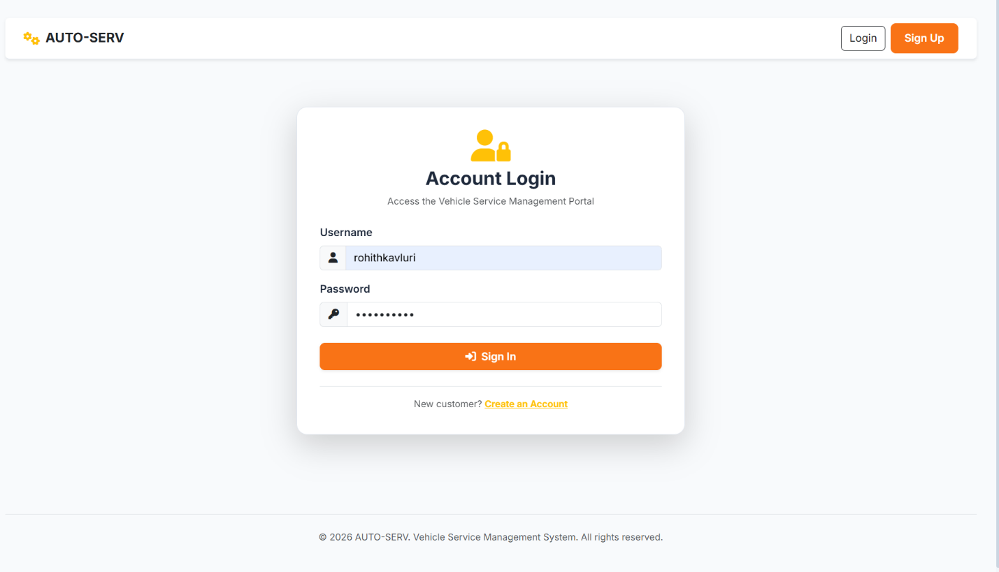
Registration Page
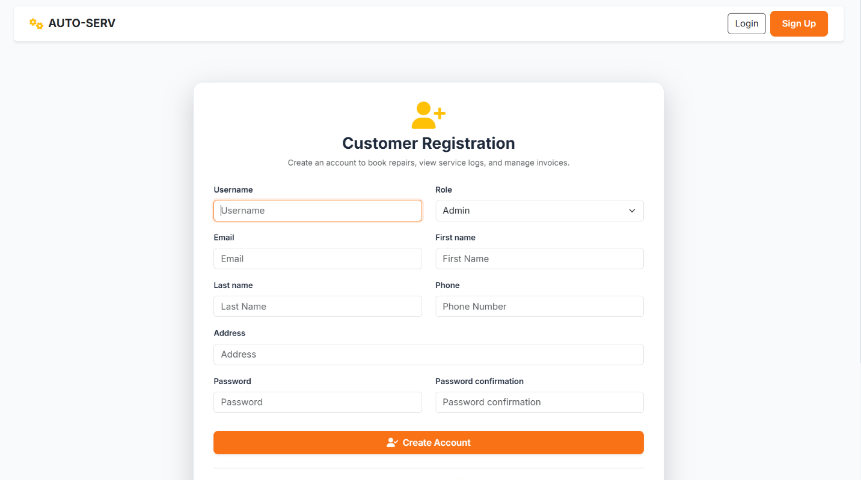
Customer Dashboard
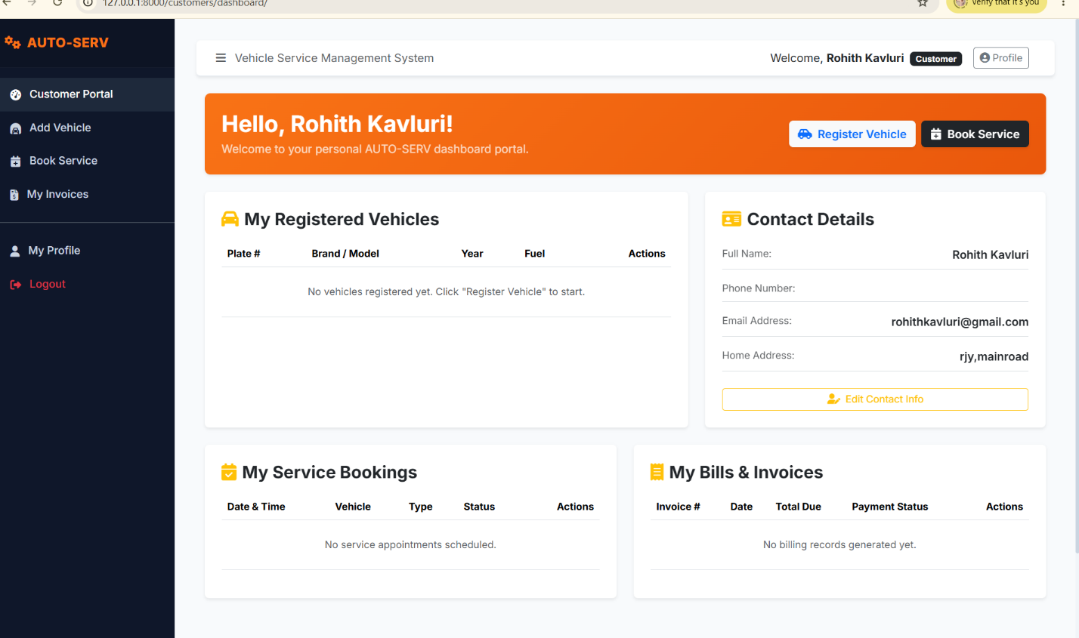
Vehicle Registration Page
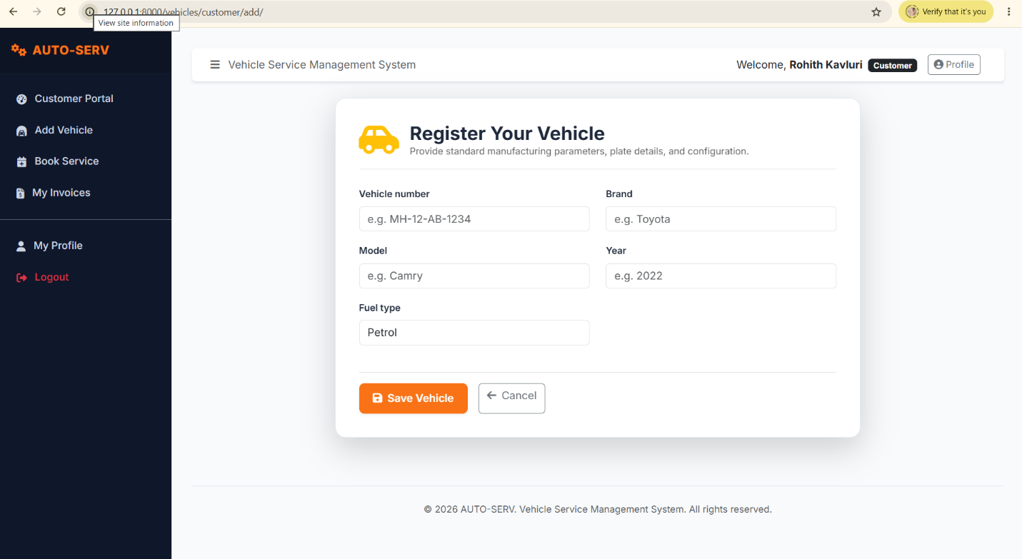
Appointment Booking Page


